Experiment 3: tree, head, and tail Commands
Aim
To execute and display the results of the tree, head, and tail commands in Kali Linux Operating System.
Process / Procedure
- Open the Kali Linux Terminal.
- Create a directory and some files.
- Use the tree command to display the directory structure.
- Create a text file with multiple lines.
- Use the head command to display the first lines of the file.
- Use the tail command to display the last lines of the file.
Commands / Code
Step 1 – Create a directory
mkdir experiment3
Step 2 – Enter the directory
cd experiment3
Step 3 – Create files
touch file1.txt file2.txt
Step 4 – Display directory structure
tree
Output:
.
├── file1.txt
└── file2.txt
Step 5 – Create a file with 10 lines
printf "Line 1\nLine 2\nLine 3\nLine 4\nLine 5\nLine 6\nLine 7\nLine 8\nLine 9\nLine 10\n" > data.txt
Step 6 – Display first 10 lines using head
head data.txt

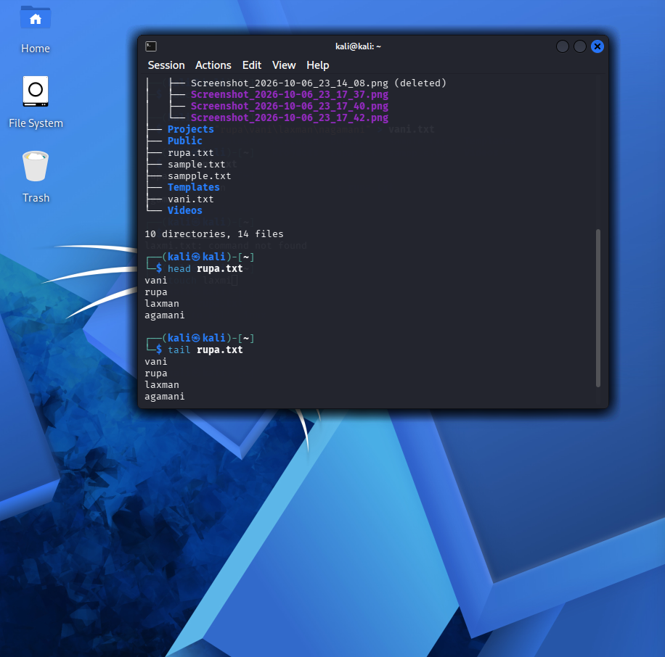
Output:
Line 1
Line 2
Line 3
Line 4
Line 5
Line 6
Line 7
Line 8
Line 9
Line 10
Step 7 – Display last 10 lines using tail
tail data.txt
Output:
Line 1
Line 2
Line 3
Line 4
Line 5
Line 6
Line 7
Line 8
Line 9
Line 10
Result
Thus, the tree, head, and tail commands were successfully executed in Kali Linux and their results were displayed.

